Design

Departures from Mark 1
- Going back to common shaft – no gearing
  - Likely means take the hit on a slower turbine shaft speed
  - Could try to go to a high shaft speed and make smaller impellers and/or pump up main engine chamber pressure, but that means making quite a low flow coefficient inducer to keep up with the demanded suction performance
- Pendulum hard the other way on ideal inlet conditions
  - Want to put each pump at the bottom of its respective propellant tank, essentially machined as part of the tank.
  - The boldest (maybe stupidest) design choice this drives is to widely separate the pumps and run their (very long) common shaft through the length of the bottom tank.
    - The rotordynamic environment is going to be… interesting
- Switch 75% ethanol to Jet-A
- No packing seals. Zero.

Impeller

Meridional
$$Shroud Curve C_{s, raw} = \frac{r_{inlet}-r_{outlet}}{\sin{ε_{ds}}Y(S) - \cos{ε_{ds} X(S)}}\left[\begin{matrix}\cos{ε_{ds} } & -\sin{ε_{ds}} \\ \sin{ε_{ds}} & \cos{ε_{ds} }\end{matrix}\right]\left[\begin{matrix}X(s) \\ Y(s)\end{matrix}\right]$$
$$X(s)=\int_{0}^{s}{\cos\left(\frac{u^{2}}{2}\right)du} Y(t)=\int_{0}^{s}{\sin\left(\frac{u^{2}}{2}\right)du} S=\sqrt{π - 2ε_{ds}}$$
$$Shroud Curve Centered C_{s} = C_{s, raw}+\left[\begin{matrix} - r_{outlet} \\ - C_{s, raw,Y} (s=S)\end{matrix}\right]$$
(so that the origin is at the impeller inlet)
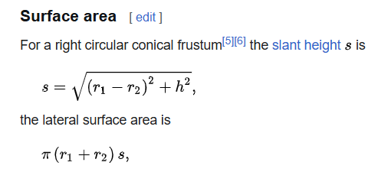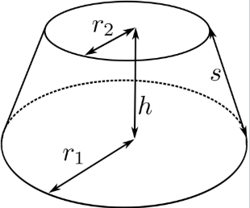
$$\cos{θ}=\frac{r_{shroud}-r_{hub}}{s} ⟹r_{hub}=r_{shroud}+s cos{θ}$$
$$c=\frac{A}{π\left(r_{shroud}+r_{hub}\right)}=\frac{A}{π\left({2r}_{shroud}+s cos{θ}\right)}$$
$$c^{2} πcos{θ + {2πr}_{shroud}c -A = 0}$$
$$c=\frac{1}{2π\cos{θ}}\left[{-2πr}_{shroud}±\sqrt{4π^{2} {r_{shroud}}^{2}+4Aπ\cos{θ}}\right]$$
$$c=\frac{r_{shroud}}{\cos{θ}}\left[\sqrt{1+\frac{A\cos{θ}}{π{r_{shroud}}^{2}}}-1\right]$$
$$c=\sec{θ}\left[\sqrt{{r_{shroud}}^{2}+\frac{A\cos{θ}}{π}}-r_{shroud}\right]$$

Inducer

Vehicle
- Make the tanks out of hvac ducting. This stuff comes in a ton of different diameters:
  - 0.79mm 304 stainless: https://www.mcmaster.com/2538K115/
  - 0.64mm, polished: https://www.mcmaster.com/18005K27/
  - 0.51mm Al, but needs seam: https://www.mcmaster.com/1773K308/
  - 0.55mm galvanized: https://www.mcmaster.com/2226K48/

Turbine
Mount in the interstage or above the TCA?
The fuel tank should be directly above the turbine in either case. Otherwise you need two separate IPS systems.
Pros to interstage:
- IPS feels easier, since leakage would have to physically route around the turbine wheel
- Probably shifts the CG forward helps vehicle stability (smaller fins required)
  - This is unclear since it is also moving the lox tank to the bottom
- Could diffuse the lox discharge directly downwards into the main injector
Pros to TCA:
- Less aluminum steel transitions. Helps with CTE and can weld more joints.
- Interstage load path is a little easier, less stuff put in bending. That loadpath is likely more critical during recovery
- Exhaust being dumped near to TCA instead of ox tank skin, which is way less risky

